API
Application Programming Interface – Referred to as API henceforth, is a mode of communication between two segments of a program.

API callbacks make development of applications much easier.

Resources: https://gorails.com/episodes/our-first-api

The following documentation gives a general insight to the API callbacks designed for this application. A more specific documentation for individual models will be made available.

- The application supports callbacks & in the form of JSON only.
- For testing API callbacks, install a API tester such as Insomnia.
- All the demo values put up in the documentation is on testing with Insomnia.

For CRUD Actions(*):
- Index - Make a GET request to “http://localhost:<port>/<model_name>.json”. This request will return a JSON array after performing a DB query, containing the attributes of the model.
- For example: Making a GET request to “http://localhost:4000/project_details.json”, returns the JSON array :

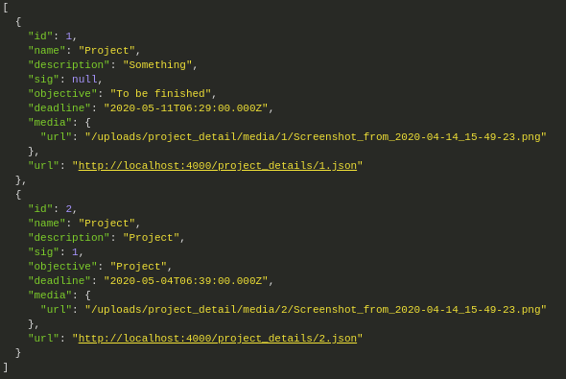
- Show – Make a GET request to “http://localhost:<port>/<model_name>/<id>.json”.
- This request will return a JSON array after performing a DB query, containing the attributes of the model with the <id> mentioned.
- For example: Making a GET request to “http://localhost:4000/project_details/2.json”, returns the JSON array:

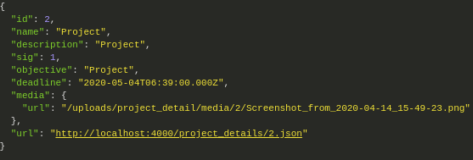
- Create – Make a POST request to “http://localhost:<port>/<model_name>.json”.
- In the post request, a JSON hash containing the attribute values of the model need to be passed.
- This request will return the array obtained in “Show” and also return a Status => 201(Created.)
- For example: Making a POST request to “http://localhost:4000/project_details.json”, returns JSON array and Status:

- Update – Make a PUT request to “http://localhost:<port>/<model_name>/<id>.json”
- In the put request, a JSON hash containing the attribute values of the model need to be passed.
- This request will return the array obtained in “Show” and also return a Status => Ok(200)
- For example: Making a PUT request to “http://localhost:4000/project_details/2.json”, returns JSON array and Status: (200)

- Delete – Make a DELETE request to “http://localhost:<port>/<model_name>/<id>.json”.
- This request will return a Status: No Content
- For example: Making a DELETE request to “http://localhost:4000/project_details/2.json”, returns Status: 204(No Content)

(*): Further specifications related to JSON hash for individual model shall have their own documentation.

Sign In:
- Make a POST request to “http://localhost:<port>/users/sign_in.json”.
- The POST request should contain a JSON hash of user’s email and password.
- For example: {“users”: {“email”: ”acm@acm.in”, “password”: “acmacm”}}
- This will return a status - 201(Created) and returns a JSON array containing users_attributes.

Sign Up:
- Make a POST request to “http://localhost:<port>/users/sign_up.json”.
- The POST request should contain a JSON hash of user’s attributes.
- For example: {“users”: {“email”: ”acm@acm.in”, “password”: “acmacm”, “password_confirmation”:”acmacm”, “name”:”ACM_NITK”, “mobile”:”1234567890”, “admin”: “1”}}.
- This will return a status - 201(Created).
- Note: Only an admin user can add a new user. In case the user is not an admin user, it will return a status - 401:Unauthorized.

Sign Out:
- Make a DELETE request to “http://localhost:<port>/users/sign_out.json”.
- This will return a status – 204(No Content)

Validate Permissions(**):
- Make a GET request “http://localhost:<port>/project_details/:project_detail-_id/validate_permissions.json”.
- This will return a set of JSON values:
- mentor – A boolean attribute which will tell if the current_user is a mentor or not for the project_id passed.
- Admin – A boolean attribute which will tell if the current_user is an admin or not.
- project_ids = JSON array containing the project_ids for which the current_user is a mentor. Returns an empty array if not a mentor for any project.

(**) - The validate permissions can be omitted once CanCanCan integration is successful.

